LinkedIn's Role in your narrative: The importance of Personal Branding

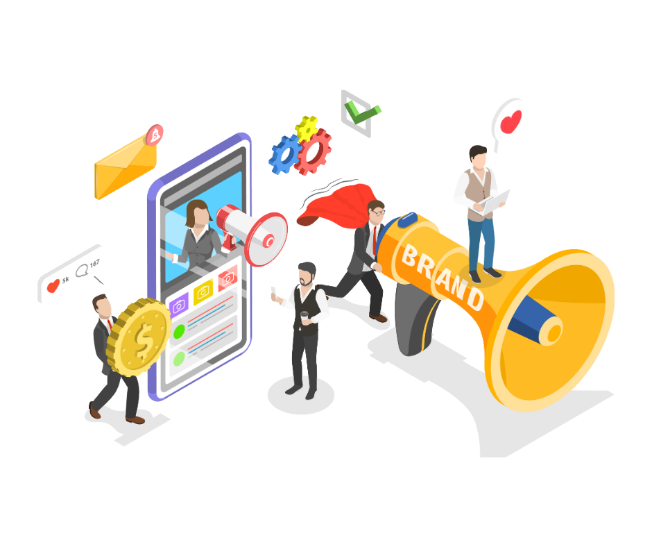

Personal branding is very important to stand out in your professional network. Everybody has their personal brand. This refers to how a person is known online. In most cases, it is known as your online reputation.

If a potential employee or client searches for your name online, the search results that display are your personal brand. It showcases who you are & what you do.

Want to build your own personal brand? Then, LinkedIn is a great place to be! Building your personal brand on LinkedIn holds significant importance for professionals in today's digital age.

With the impressive focus on professional networking, career & business opportunities, LinkedIn provides a wonderful platform to showcase your talents & abilities. So read to the end to know the importance of LinkedIn personal branding & also read about the six questions you can ask yourself to effectively build your personal brand on LinkedIn.

What is my Goal?

This is a great question you can ask yourself. The answer to this question will determine the purpose of you being on LinkedIn & will further help you to shape your personal brand accordingly.

It varies depending on individual goals & career aspirations. It can range from career advancement, business development to knowledge sharing & recruitment & hiring.

You need to establish metrics to measure the success of your LinkedIn personal branding efforts, such as profile views, connection growth, engagement metrics, & opportunities generated & regularly review your progress against these metrics & adjust your strategy as needed to achieve your goals effectively.

By setting clear goals for your LinkedIn personal branding efforts & consistently working towards them, you can build a strong & impactful online presence that enhances your professional reputation, expand your network, & creates new opportunities for career growth & advancement.

Why should I optimize my profile?
A perfectly optimized profile includes the following
- Profile picture
- Headline
- Summary
- Experience
- Skills
- Recommendations
- Engagement
- Media
A well optimized LinkedIn profile serves as the best first impression to showcase your skills, experience & achievements effectively. It enhances your credibility, professionalism & demonstrates that you take your professional presence seriously.
LinkedIn is a professional platform, so it is a must to keep your profile professional & polished.

Why should I expand my connections?

Connections are the driving force to build your personal brand & grow yourself professionally. They provide you networking opportunities along with opportunities for collaboration & career advancement

Many connections open many doors to find suitable opportunities that can make you stand out in your own way. So, grab every opportunity to grow your connections & maintain regular communication to add value & foster trust.

Why should I share relevant content?
This is a great way to engage with your network, establish yourself as a leader in your industry & build meaningful relationships.
You can share articles, blogs, industry news & insights depending on the interests & preferences of your connections.

Studies show that posts on LinkedIn with visual content drive 98% more comments than posts without visual content. So as far as possible, try to use relevant visuals to complement your written content & capture the attention of your audience.

Don't just repost but add your own insights to make the content more likely to be seen & read. Being consistent is always the key to growth.

Why should I engage with my network?

This is essential for building & maintaining relationships on LinkedIn. This not only means to be consistently posting great content but also to reading & seeing other content.

You can like & comment on posts posted by your connections, participate in discussions & share your perspectives. By personalizing messages, acknowledging & congratulating your connections for their achievements, you can show that you support them & this will help to make your connections more meaningful.

Which cross platform tools can I use?

You can make use of the various cross platform tools available for content creation, social media management or CRM integration. LinkedIn provides tools like LinkedIn Pages, LinkedIn Ads & LinkedIn Analytics which can be integrated for a comprehensive media strategy. Platforms like Hootsuite, Buffer or Social Sprout allow you to schedule posts, monitor engagement & analyze your performance.

Similarly, PaintMinds helps you to optimize your profile to the utmost level. It helps you build your profile in such a way that it can help you face the challenges of the real world. Your LinkedIn profile is your brand & only you have the power to shape it!

Conclusion
Investing in your personal brand on LinkedIn is an investment in your long-term success & career sustainability. A strong & authentic personal brand withstands changes in the job market & industry trends, providing you with a solid foundation for navigating future career transitions, challenges, & opportunities.

Keywords- LinkedIn role description | LinkedIn role | LinkedIn role description examples | LinkedIn personal branding | Importance of personal branding

Title Tag – Answers to Top 6 questions about Personal Branding

Meta description – LinkedIn is a wonderful tool when it comes to building your personal brand. But how can you create your profile that establishes your personal brand effectively? Tune in to know more.

Meta tag – Effectively build your Personal Brand – How can you do it? | PaintMinds

